1. SELECT * FROM transactions ORDER BY amount DESC;

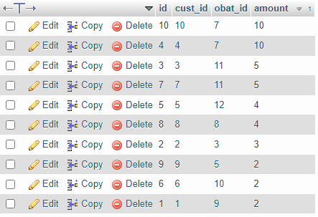

1. SELECT * FROM transactions WHERE amount <= 5 ORDER BY amount DESC;

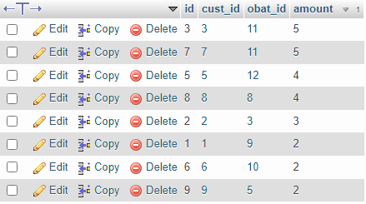

1. SELECT name, price, stock, supplier_id FROM obat ORDER BY stock ASC;

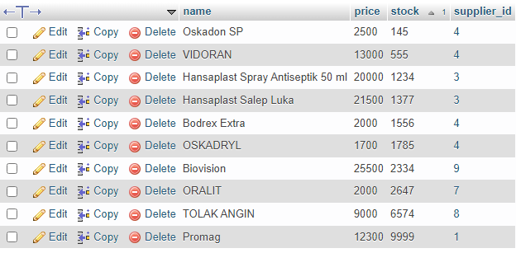

1. SELECT * FROM obat WHERE symptoms LIKE '%Sakit%';

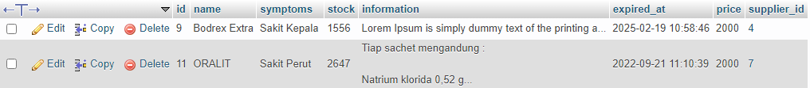

1. SELECT * FROM obat WHERE symptoms LIKE '%Suplemen%';



1. SELECT supplier_id, SUM(stock) AS total FROM obat GROUP BY supplier_id;

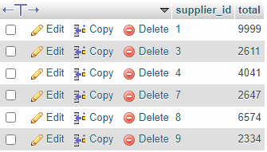

1. SELECT supplier_id, SUM(stock) AS total FROM obat WHERE supplier_id = 4 GROUP BY supplier_id;



1. SELECT symptoms, SUM(stock) AS total FROM obat WHERE symptoms LIKE '%Suplemen%' GROUP BY symptoms;



1. SELECT obat_id, SUM(amount) AS total FROM transactions WHERE obat_id = 11 GROUP BY obat_id;



1. SELECT name, symptoms, stock AS total FROM obat WHERE stock < 1000 ORDER BY name DESC;

